Half Tone

📘 Definition
# Source: AI Source: Provided by: [Data Path: Persons Table -> ID Column: 1, Name_En Column: Motasem Essam] -> From: [ChatGPT] on [5/2/2026]
Half Tone (or Midtone) is the area on an object that is partially lit—it is between the bright light (highlight/center light) and the dark shadow.
It represents the middle level of brightness, not too bright and not too dark.

🎨 How half tone appears
# Source: AI Source: Provided by: [Data Path: Persons Table -> ID Column: 1, Name_En Column: Motasem Essam] -> From: [ChatGPT] on [5/2/2026]
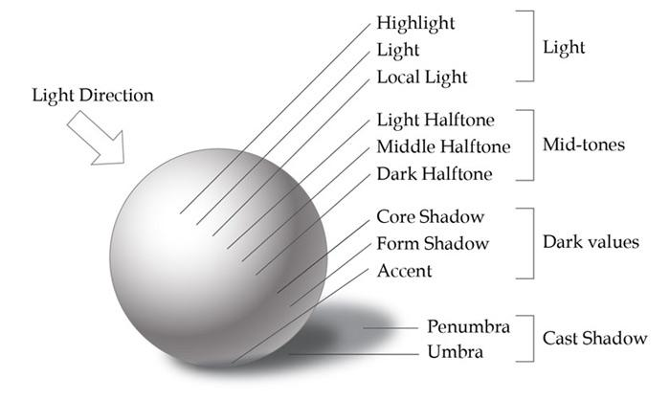
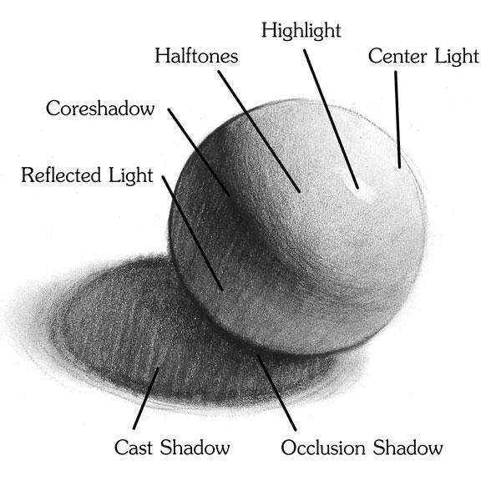
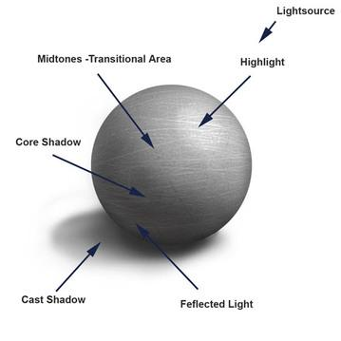
On a shaded object:
- ✨ Highlight → brightest
- 💡 Center Light → bright
- 🎨 Half Tone → medium brightness
- 🌑 Core Shadow → darkest on object

🧠 Simple example
# Source: AI Source: Provided by: [Data Path: Persons Table -> ID Column: 1, Name_En Column: Motasem Essam] -> From: [ChatGPT] on [5/2/2026]
Think of a ball under light:
- One side is very bright
- The opposite side is dark
- The area in between → Half Tone

🎯 Why half tone is important
# Source: AI Source: Provided by: [Data Path: Persons Table -> ID Column: 1, Name_En Column: Motasem Essam] -> From: [ChatGPT] on [5/2/2026]
- Creates a smooth transition between light and shadow
- Makes objects look round and realistic
- Shows the natural shading of surfaces

⚙️ Key features
# Source: AI Source: Provided by: [Data Path: Persons Table -> ID Column: 1, Name_En Column: Motasem Essam] -> From: [ChatGPT] on [5/2/2026]
- 🎨 Medium brightness (between light and dark)
- 🔄 Smooth transition area
- 📍 Found between center light and shadow
- 🧩 Essential for realistic shading

🚀 In short:
# Source: AI Source: Provided by: [Data Path: Persons Table -> ID Column: 1, Name_En Column: Motasem Essam] -> From: [ChatGPT] on [5/2/2026]
Half Tone = the middle shading area between light and shadow on an object.

